The Newcomers’ Guide to the English Translation Section

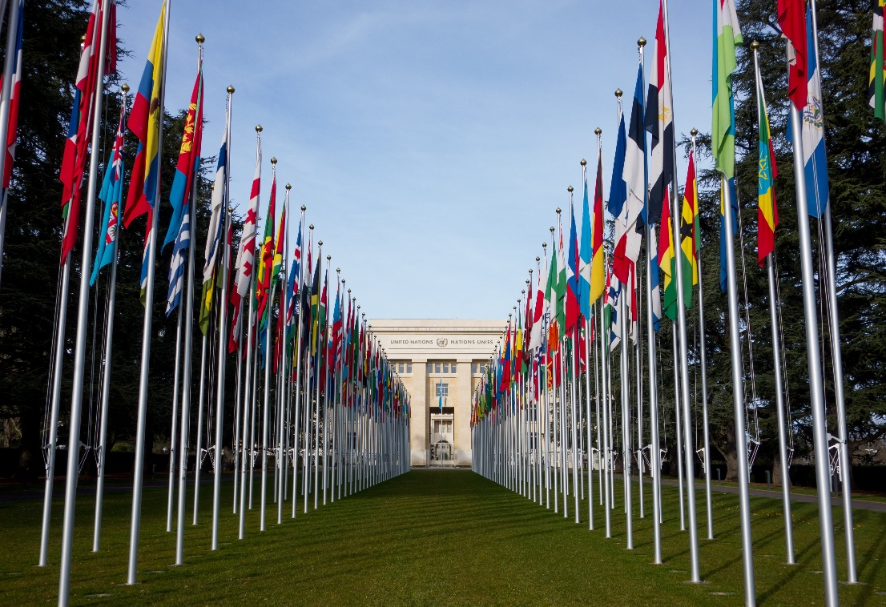

Welcome to the United Nations Office at Geneva (UNOG)! For over 75 years, the translation services of the United Nations Secretariat have been helping the now 193 States Members of the United Nations to communicate. By producing documentation in the six official languages of the United Nations, we are also at the forefront of multilingualism in the Organization and the world in general.
We are proud to place our skills at the service of the principles of the Charter of the United Nations. Our work is challenging: it requires political sensitivity, interest in current affairs, analytical skills and, of course, superior language skills. Not only do our translations inform decision- and policy-making at the highest level; they also contribute to holding Member States accountable for their human rights record, keeping key global issues in the spotlight and developing international law. By serving as a historical record, our summary records become a key part of the lasting legacy of the Organization’s work.
We are always looking for talented translators with the right language combinations and skills and we look forward to showing you what our job involves. We trust that you will find it as exciting and rewarding as we do. This guide contains information specific to the English Translation Section, as well as practical information on working at UNOG (a map of the Palais des Nations and tips about living in Geneva can be found in the annexes). It is meant as an overview; you will receive more detailed information and training in your first few days with us. We hope that you will find it useful and will help us to improve it during your time with us.

Contents
The English Translation Section
- Where we are
- Who we are
- What we do
Your time in the English Translation Section
- Your first day
- Dress code
- What to expect
- How to prepare
- UNOG Gender Policy
Practical information
- Finding your way around the complex
- Working hours
- Lunch and coffee breaks
- Services
Annex 1: Maps
Annex 2: Geneva Basics

The English Translation Section
Where we are
Location
The English Translation Section, also known as ETS, is located on the sixth floor of the E building at the Palais des Nations. (Detailed instructions on how to find our offices can be found under “Your first day” below.)

Contacting us
The main point of contact for the Section is the front office (E-6040), which is staffed by the Senior Documents Assistant, Antonella Balzerano, who can be reached at +41 22 917 59 42 or trad_sec_eng@un.org.
Who we are
The Section currently has 24 full-time staff, including the Chief and the Senior Documents Assistant.
The Chief of Section heads the team and is accountable to senior managers, including the Chief of the Languages Service, which the Section falls under, and the Director of the Division of Conference Management, which the Languages Service falls under, for all aspects of the Section’s work.
The Section has three senior revisers, ten revisers, seven translators/précis-writers, one terminologist and one terminology assistant. The Documents Assistant is responsible for front office work, including distribution of work, certain administrative duties and record-keeping. The Section works closely with desktop publishing assistants, who proofread and format the documents that we produce, and the organizers of the meetings for which we prepare summary records.
Chief of Section: Ms. Nicole Maguire | Senio Documents Assistant: Ms. Antonella Balzerano
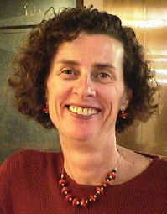 | 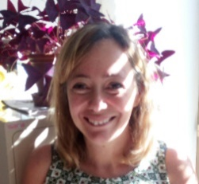

What we do
The English Translation Section is primarily responsible for producing summary records and for translating into English documents received in the five other official languages of the United Nations. Our clients are diverse and include the Office of the United Nations High Commissioner for Human Rights (OHCHR), the Economic Commission for Europe (ECE), the United Nations Conference on Trade and Development (UNCTAD), the International Law Commission and the Conference on Disarmament. OHCHR accounts for over 60 per cent of our translation work. Most of the documents we receive in that connection are prepared by Member States or the Geneva-based human rights treaty bodies.
Producing summary records accounts for 60 per cent of the Section’s workload and is referred to as “précis-writing”. Staff draft and revise summary records of meetings of the 10 treaty bodies and the International Law Commission. As this is an important part of the Section’s work, training is provided to all newcomers in this area. Précis-writing is an intensive task, but it also gives staff first-hand knowledge of the work of the United Nations.
Your time in the English Translation Section
Your first day
If you are working off-site, please send an email message to trad_sec_eng@un.org the morning of your first workday to confirm that you are ready to start your day.
If you are working on-site, the morning of your first workday, you should go directly to the main entrance at the Pregny Pavilion, on Avenue de la Paix (Appia bus stop, or walk up the road from Place des Nations).
To get your badge, you will need to explain to the person assisting you that you are starting your first contract and show him or her your passport and the letter of offer that you received from human resources. If you have any problems, please contact the Documents Assistant, Ms. Antonella Balzerano, at +41 22 917 59 42 or the Chief of Section, Ms. Nicole Maguire, at +41 76 691 0206.
Once you have your badge, you will, for the duration of your contract, be able to enter the United Nations complex (called the Palais des Nations or just “the Palais”) through the turnstiles at the Pregny entrance or the turnstiles at the Peace Gate on the Place des Nations (see map in annex 1.A) by holding your badge against the magnetic reader (you may hear a click as the turnstile unlocks). You might also have to show your badge to a security guard. Please note that, when in the United Nations complex, you should always have your badge with you.
Once inside the complex, please proceed to door E40 of building E (see map in annex 1.A). Because of construction work, you cannot reach the E building through any of the other buildings; you have to walk outside. The walk might take you 10 minutes. Enter through door E40 and take one of the two elevators that will be on your right to the sixth floor. When you exit the elevator on the sixth floor, start down the hallway in front of you. The second door on the right (after you enter the hallway) will be to the office of the Documents Assistant (E-6040). Please check in with her so that she knows that you have arrived and are ready to start your day.
You will also need to pass by the office of Ms. Mireille Brice (E-5082, on the fifth floor) on your first day to get a name plate for your office door. If she is unavailable, Mr. Fabrice Monet (same office, E-5082) can assist you.
Lastly, you will have to take care of all human resources formalities, including submitting an application for a carte de légitimation (a special Swiss residence and work permit for employees of international organizations) if your contract period is longer than four weeks. Please contact Ms. Arlinela Wetzel at arlinela.wetzel@un.org or write to freelancers.hrms@un.org if you have any questions about any human resources requirements for freelancers.
Dress code
While the dress code varies from department to department, proper business attire and a professional appearance are an important element in the overall impression staff make on colleagues, visitors and client offices at the United Nations. In ETS, we generally wear business casual attire unless we are covering a meeting (i.e. attending a meeting that we will be preparing a summary record for) in person, in which case we wear slightly more formal clothing. Please note that, as a new staff member or freelancer, you will have to attend some such meetings in person during your training period.
What to expect
In your first few days in the Section, you will be assigned a person to help you with induction, training, the use of technological tools and other matters, and other members of the Section will be involved in providing you with assistance and feedback. Workshops are held periodically on various topics related to our work; you are encouraged to attend any that take place during your time with us.
Most members of the Section now telecommute two or three days a week, so you will rarely see all ETS staff in the office at the same time. However, we do have virtual Section meetings (called “huddles”) twice a week, on Wednesdays and Fridays at 10 a.m., that everyone does try to attend. The huddles are held on Microsoft Teams. You will be a member of the ETS “team” on Teams and can join the huddles from the team’s “General” channel.
Précis-writing
As a newcomer, you will be sent as soon as possible for dry runs, where you will shadow another précis-writer. The meetings that we cover take place either in the Palais des Nations or at the Palais Wilson (see annex 1.B). Although you will have to attend some meetings in person during your training period, we generally have the option of attending meetings either in person or virtually, via Zoom or other platforms.
We cover meetings in teams that are made up of between two and four précis-writers, who each draft a part of the summary record, and a reviser, whose role is to turn the parts into a cohesive whole. There are usually two 3-hour meetings per day, from 10 a.m. to 1 p.m. and 3 to 6 p.m.; one team covers the mornings and another the afternoons. Each précis-writer takes notes on a 45- or 90-minute segment of the meeting (a period known as a “take”), depending on the size of the team, and then drafts a summary of, or “writes up”, his or her take. For each 45-minute take, précis-writers are allocated one working day (including the time spent in the meeting room or spent watching the meeting online) to draft their portion of the record, which can be anywhere between 1,000 and 1,500 words. Meetings are recorded to provide a sound file as back-up.
You will need to have or develop good note-taking skills, as the pace of delivery can at times be high. Familiarity with the treaty being discussed is essential to understanding the proceedings.
How to prepare
As much of the translation and précis-writing work that we do revolves around the work of the treaty bodies, it could be interesting for you to find out a little bit about them before you arrive. (However, rest assured that you will also receive information about them after your arrival.)
The treaty bodies have monitoring obligations under various human rights treaties and are supported in their work by the secretariat of OHCHR.
You can find out about the 10 treaty bodies and the treaties that they deal with through this page of the OHCHR website: What are the treaty bodies? You will notice that the name of each treaty body is followed by an acronym or an abbreviation – these are what we normally use internally, within ETS, when we talk about the treaty bodies.
You can find general information about their work through the page What the treaty bodies do. Some of the items that are discussed on this page, such as the reports of States parties and individual complaints, are the subject of many of the meetings that we write summary records for.
The States parties’ reports are the core of a reporting cycle, a cycle that also involves written questions from the treaty body to the State party, a dialogue between the treaty body and a delegation from the State party and the issuance of recommendations by the treaty body to the State party in the form of “concluding observations”.
To get a sense of this cycle, you might find it helpful to glance at the following web page, on the seventy-fourth session (a “session” is a two- to four-week period of meetings) of the Committee on Economic, Social and Cultural Rights: CESCR seventy-fourth session. In the section for each State party, you will find links to the summary records that were prepared for the dialogues that took place between the Committee and a delegation from that State party.
While you are with ETS, you will be attending meetings of one or more of the treaty bodies, so you will see how the dialogue with a State party delegation unfolds; recordings of such meetings are also available on UN Web TV. You might also find it interesting to look through the UNOG annual report and the United Nations Editorial Manual. You will receive much fuller information about the United Nations précis-writing manual and other tools and resources during your time with us in the Section.
UNOG Gender Policy
In 2016, UNOG adopted a policy for gender equality and the empowerment of women. The policy is designed to establish an inclusive organizational culture free from gender bias and discrimination and to improve the representation of women at all levels. It can be found here.
Practical information
Finding your way around the complex
An app called UNOG Directory Search can be downloaded onto a smartphone to find the main committee meeting rooms and other on-site services at the Palais des Nations.
Working hours
Working hours are 8.30 a.m. to 5.30 p.m., with an hour’s break for lunch. If you wish to start earlier or later, you should ask the Chief. Hours are more flexible when you are précis-writing, if you can respect the deadlines for handing in your summary record.
If you are delayed or sick, please contact the Documents Assistant before 9 a.m. (+41 22 917 59 42 or trad_sec_eng@un.org).
Lunch and coffee breaks
Cafeteria
The main cafeteria serves hot meals and is located on Level 0 of the Palais des Nations. It provides a large selection of dishes and is reasonably priced by Geneva standards. The menu rotates daily and meals can be ordered to go. The menu can be consulted here.
Note that interns are entitled to a special price of 8 CHF (present your badge to the cashier) for the Express, Natura, Wellness and vegetarian menus, pizza marguerite and Napolitaine pasta.
Coffee/snack bars
There are several coffee/snack bars throughout the Palais. However, because of construction, only the Serpent Bar, located on Level 1 of the E building, and the Grab & Go, located in the H building, are currently open.
The opening hours for the cafeteria, the Serpent Bar and the Grab & Go are all provided at the very bottom of the page with the cafeteria menu (link provided above).
Vending and coffee machines are available on Level 1 of the E building (in the vicinity of meeting room XXVI). There is also a coffee machine on Level 2 of the E building, near door E39.
Staff lounge
The staff lounge is located in room E-5110 and has a fridge, small freezer and microwave.
Other food options
If you would like to eat outside the Palais, there are some restaurants in the area. You can also eat at the cafeteria at the Palais Wilson and at other nearby organizations, such as WIPO, WMO, WTO, UNHCR and the Red Cross. During the summer, there is also a restaurant at the Club de la Plage de l’ONU, a beach reserved for UN staff, located by the lake and within walking distance of the Palais. You will need to bring your badge and pay the small entry fee.
Services
Medical Service
There is a walk-in clinic from 8 a.m. to 5 p.m. Monday to Friday (ext. 72520). It is located on Level 1 of the S building (door S1) (see map in annex 1.A). In a medical emergency, dial 112.
SAFI
SAFI is a staff-owned shop that sells a range of products, including luxury goods (watches, jewellery, clothing and make-up), Swiss souvenirs, luggage, toiletries, chocolates, alcohol, food, snacks and cold drinks. Many of the prices are cheaper than in the rest of Geneva. It is located on Level -1 of the S building and can be reached through door S1. It also provides certain postal services.
Banks and ATMs
You can find a UBS branch and ATMs near door 41 of the E building. The door is not labelled on the map in annex 1.A, but the UBS branch is designated by the red number 10 in a circle. The ATMs dispense euros as well as Swiss francs.
UN Bookstore
The UN Bookstore is located inside door 40 of the E Building and sells a great selection of books in English and French on UN-related topics, as well as UN souvenirs.
UN stamps
UN stamps are available at the United Nations Postal Administration counter located behind the UN Bookstore in the E building. It is open from 11 a.m. to 5 p.m., Monday to Friday.
Classified ads
Classified ads (apartments, concert tickets, furniture, etc.), as well as temporary job vacancies at UNOG, are listed on the UNOG intranet, accessible only from inside the Palais des Nations. Classified ads are also posted in the hallway between door 6 and the cafeteria.
Cultural Kiosk
The CAGI Cultural Kiosk, located on Level 1 of the E building, offers cultural and tourist information. There are often special deals on theatre shows and concerts for UN staff.

Annex 1.A: Palais des Nations
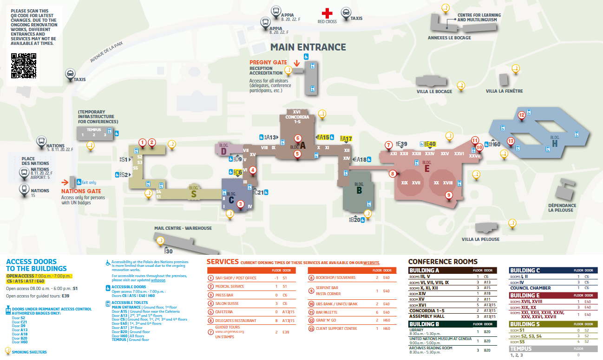
Annex 1.B: Location of Palais Wilson
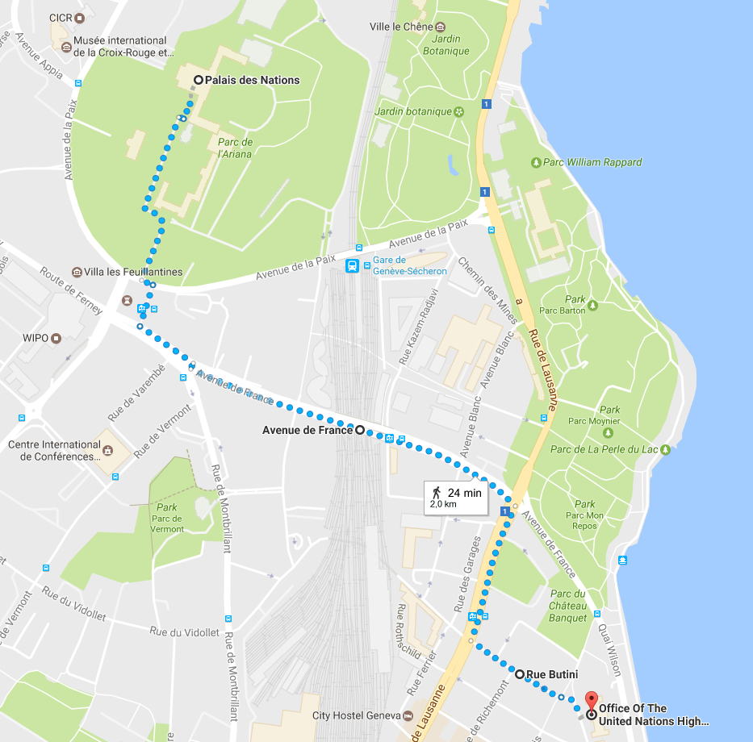

Annex 2: Geneva Basics
Your arrival
Geneva Airport
Geneva Airport (Cointrin) is conveniently located just minutes outside of Geneva.
The train is the fastest way to the centre of Geneva (under 10 minutes). It will take you from the airport itself directly to Gare Cornavin, the main train station. You can also reach various places in Geneva and just over the border in France from the airport by bus. You can check routes and schedules on tpg.ch. This map shows where the airport train station and bus stops are located. A taxi will cost 35‒45 CHF to the centre of town, depending on traffic.
Gare Cornavin
Gare Cornavin is the main train station in Geneva, as well as a major hub for tram and bus lines. This map shows where the tram and bus stops at and around the station are located. There is also a high-speed train to Paris (about three hours) and other destinations in France.
Money
The currency in Switzerland is the Swiss franc (CHF). The cost of living in Geneva is quite high — do some research online to get an idea of what to expect.
First-time freelancers who wish to open a Swiss bank account may do so under certain conditions. Please check with your human resources contact person (most likely Ms. Arlinela Wetzel, who can be reached at arlinela.wetzel@un.org) or write to freelancers.hrms@un.org to see if you need to open a Swiss bank account for the payment of your salary.
Public transportation
Public transportation in Geneva is run by Transports publics genevois (TPG). Tickets cost 3 CHF for one hour of transportation around Geneva (2 CHF if you’re only going 3 stops or fewer) and can be purchased from machines at stops. Note than not all machines take cards or give change. It is also possible to purchase bus tickets by SMS (information is available at http://www.tpg.ch/billets-sms) if you have a Swiss or French SIM card.
You may want to consider buying a monthly TPG pass, which can be purchased online or at a TPG office. This pass will allow you to use all the buses and trams in the Geneva area and the train to the airport, as well as the mouettes (taxi boats) on the lake.
Once you have your ticket or pass, you do not need to present it, scan it or do anything else with it after boarding your tram or bus. However, spot checks are occasionally carried out, and if you are caught without a ticket on public transportation, you will have to pay a hefty fine.
For details on fares, routes, schedules and stops, visit tpg.ch or download the free app.
Groceries and shopping
The two main supermarket chains are Migros and Coop. The closest supermarket to the UN is the Coop behind UNHCR, which sometimes offers discounts after 5 p.m. There is also a supermarket in the basement of the Manor department store, close to Gare Cornavin, which is somewhat more expensive than Migros and Coop. There are several weekly markets with local produce, including one at Rive on Saturday mornings and at Plainpalais on Sundays. There is also a weekly flea market at Plainpalais on Saturdays.
Another option is to shop for groceries in France, which is often cheaper than Geneva. However, some customs duties may apply on large quantities of meat, dairy and alcohol. See https://www.ch.ch/en/how-clear-personal-goods-purchased-abroad/ for more information.
The main shopping area is on the stretch between Bel-Air Cité and Rive. Rue du Rhône runs parallel and boasts many of the world’s most famous brands and designers. The old town, Plainpalais and Carouge also have interesting boutiques. There are two main malls, Balexert and La Praille, both accessible by public transportation.
Keep in mind that most supermarkets and shops close early in Geneva, usually at 6 or 7 p.m. on weekdays, except on Thursday evenings, when they stay open later. Almost all shops and supermarkets are closed on Sundays except for those at Gare Cornavin and the airport and some smaller grocery and convenience stores in the Servette, Pâquis and Plainpalais neighbourhoods.

